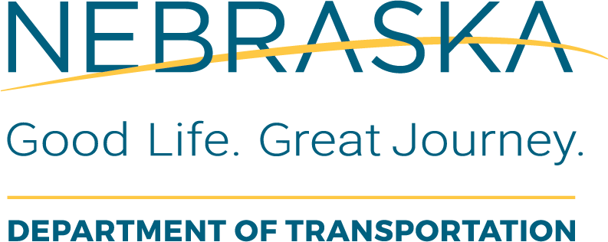 | Railroad  Railroad Special Provisions Review Checklist  LAD PC is responsible for completing boxes shaded in gray prior to routing of checklist.
Local Public Agency (LPA): |  | LPA Responsible Charge: | PE Consultant:
State Project No.: |  | Project Name and Location:
State Control No.: |  | Date Received by NDOT:

This form was completed by (insert name and date review was completed):
NDOT Local Assistance Division Project Coordinator : | Date:
NDOT Rail Section: | Date Received by NDOT:

Instructions for Use: This form is to be completed by the NDOT Rail Section.
Task Description or Questions |  | Completed |  |  | If No, Define Corrective Action | Details or Information Used to Verify Content | Additional Comments
 |  | Y | No | N/A | If No, Define Corrective Action | Details or Information Used to Verify Content | Additional Comments
1. | Do special provisions include: Contractor Requirements? |  |  |  |  | Special Provision Checklist for Appropriate Railroad
2. | Do special provisions include: Insurance Requirements? |  |  |  |  | Special Provision Checklist for Appropriate Railroad
3. | Do special provisions include: Work Windows? |  |  |  |  | Special Provision Checklist for Appropriate Railroad
4. | Do special provisions include: Train Delay? |  |  |  |  | Special Provision Checklist for Appropriate Railroad
5. | Do special provisions include: Additional right-of-way? |  |  |  |  | Special Provision Checklist for Appropriate Railroad

