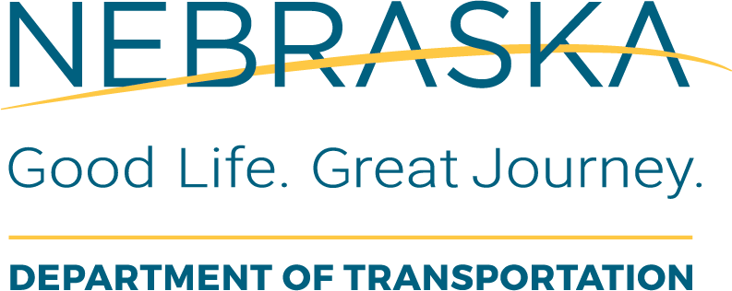 |  | ROW  ROW Project File Review Checklist
Instructions for Use: This form should be completed by the LPA ROW Coordinator.

Local Public Agency (LPA): |  |  | LPA Responsible Charge:
State Project No.: |  |  | Project Name and Location:
State Control No.: | Form Completed By (Print Name): |  | Form Completed By (Signature): | Date:
No Additional ROW Required |  |  |  | Y | N | NA
1. LPA Right of Way Certificate (AP-19)?
2. A short letter from the LPA explaining the project?
3. NDOT Right of Way Certificate
Additional ROW Is Required |  |  |  | Y | N | NA
4. LPA Right of Way Certificate (AP-18)
5. NDOT Right of Way Certificate
6. QA-QC 1 ROW Plan Checklist signed, dated and in file?
7. QA-QC 2 ROW Cost Estimate Checklist signed, dated and in file?
8. QA-QC 3 Appraisal Checklist for each tract signed, dated and in file for each tract valued?
9. QA-QC 4 Relocation Assistance Checklist signed, dated and in file for each file with a displacement?
10. QA-QC 5a Donation Tract File Checklist signed, dated and in file for each tract donated?
11. QA-QC 5b Acquisition Tract File Checklist signed, dated and in file for each tract acquired?
Remarks:

