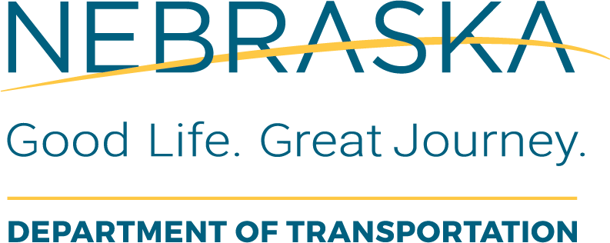 | Project Closeout  Final Review Section Final Review
Instructions for Use: This checklist will be completed by the NDOT Construction Division Final Review Section after the District Reviewer has completed checklist 14-40. Refer to the NDOT Final Review Process Manual for Details.
Local Public Agency (LPA): |  | LPA Responsible Charge:
State Project No.: |  | Project Name and Location:
State Control No.: |  | Date of Review: | This Form was Completed By:

Item  # | Task Description or Questions | Completed |  |  | If No, Define  Corrective Action | Details or Information  Used to Verify Content | Additional Comments
Item  # | Task Description or Questions | Yes | No | N/A | If No, Define  Corrective Action | Details or Information  Used to Verify Content | Additional Comments
1. | Have all supporting documents listed on the Transmittal Letter been received?
2. | Has all documentation of Time Extension and approvals been included in the file?
3. | Did the District Reviewer enter the Date Final Submitted to the Lincoln Construction Office in Key Dates Module of SMGR

