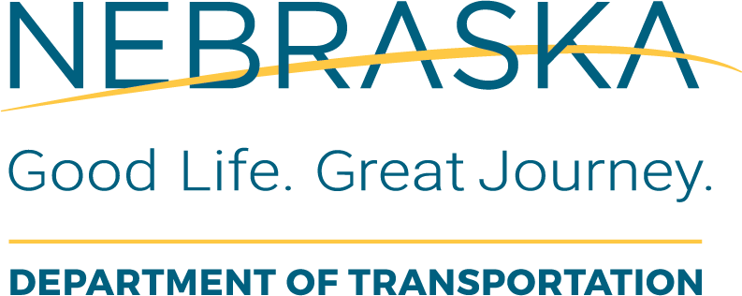 | Consultant Services  Professional Services Agreement Closure Checklist
This form is to be completed by the NDOT Agreements Section, after receiving the Notification of Completion (NDOT-39a) form from the LAD PC (for PE) or the Project Construction Conformity Certification and Closeout (NDOT-299) form from the State Representative (for CE), which was approved by the LPA RC indicating that the work under the agreement has been completed.
The agreements section will add a copy of this completed checklist to the project file.
Local Public Agency (LPA): |  | LPA Responsible Charge:
State Project No.: |  | Project Name and Location:
State Control No.: |  | Date of Review: | This Form has been Completed By:
Phase of Work:
PE CE

Pre-Audit Request
Task Description or Questions |  | Completed |  |  | If No, Define  Corrective Action | Details or Information Used to Verify Content | Additional Comments
 |  | Yes | No | N/A | If No, Define  Corrective Action | Details or Information Used to Verify Content | Additional Comments
1. | For CE and PE agreements, did the LPA RC submit the completed final NDOT-54 Consultant Evaluation Form? |  |  |  |  |  | Consultant Evaluations are required for all service agreements that is greater than or equal to $30,000
2. | Have all the invoices been submitted by the Consultant and paid?
3. | If applicable, has the entire eligible fixed-fee-for-profit been billed? |  |  |  |  |  | If no, the corrective action will be for the agreements section to request an invoice from the consultant.
Once all pre-Audit questions on this checklist have been answered “Yes”, the agreements section must request an Audit.
Enter Audit Request Date Here:
Once the Audit Report has been received by the Agreements Section: Enter Date the Audit was received here:
Task Description or Questions |  | Completed |  |  | If No, Define  Corrective Action | Details or Information Used to Verify Content | Additional Comments
 |  | Yes | No | N/A | If No, Define  Corrective Action | Details or Information Used to Verify Content | Additional Comments
4. | Has the final audit been reviewed and approved or revised by the Agreements Engineer or designee? |  |  |  |  |  | A copy of the final audit report and supporting documentation should be placed in the project file on Falcon.
5. | Has a final invoice been submitted to the Controller Division?
6. | Has the Agreements section received notification from the Controller Division that the final invoice has been processed?

