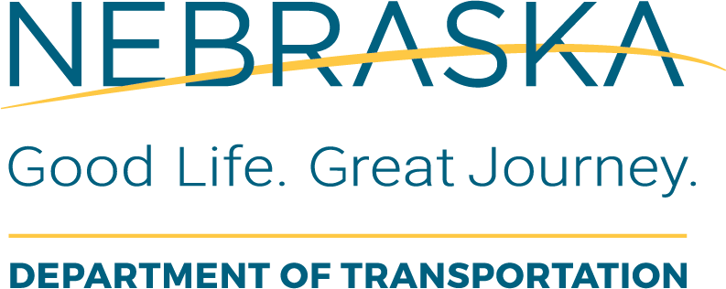 | Project Closeout  District Reviewer Final Review
Instructions for Use: The NDOT District Reviewer will complete this form after the NDOT state rep has approved the Checklist 14-20 LPA RC Final Review Process (filled out by the LPA RC). The District reviewer will add this completed checklist to the final comp file.
Local Public Agency (LPA): |  | LPA Responsible Charge:
State Project No.: |  | Project Name and Location:
State Control No.: |  | Date of Review: | This Form was Completed By:

Item  # | Task Description or Questions | Completed |  |  | If No, Define  Corrective Action | Details or Information  Used to Verify Content | Additional Comments
Item  # | Task Description or Questions | Yes | No | N/A | If No, Define  Corrective Action | Details or Information  Used to Verify Content | Additional Comments
1. | Does the LPA - RC checklist assure that the Final Review Process has been followed?
2. | Have all supporting documents been submitted?

