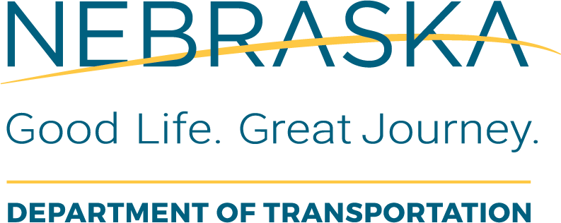 | Consultant Services  Review of the Post Negotiation Documentation
Instructions for Use: This form is to be completed by the PC to review the negotiation documentation (Negotiation Memo, Negotiated Scope of services, negotiated fixed fee worksheet and Consultant Final fee proposal) before preparing the agreement for projects that have federal or state funds included.
Local Public Agency (LPA): |  | LPA Responsible Charge:
State Project No.: |  | Project Name and Location:
State Control No.: |  | Date of Review: | This Form was Completed By:
Type of Agreement:  Original Supplemental |  | Phase of Work:  PE or CE
Negotiation Memo Review
Item  # | Task Description or Questions | Completed |  |  | If No, Define  Corrective Action | Details or Information Used to Verify Content | Additional Comments
Item  # | Task Description or Questions | Yes | No | N/A | If No, Define  Corrective Action | Details or Information Used to Verify Content | Additional Comments
1. | Does the memo include a summary of the negotiated changes when compared with the pre-negotiation memo?
2. | Does the memo include a discussion of how the differences were resolved, and justifications for cost adjustments, made during the negotiation process? |  |  |  |  |  | Indicate where the scope or effort was adjusted as part of the negotiation.
3. | Is the negotiation memo signed by the RC?
Consultant Final Scope and Fee Proposal Review
Item  # | Task Description or Questions | Completed |  |  | If No, Define  Corrective Action | Details or Information Used to Verify Content | Additional Comments
Item  # | Task Description or Questions | Yes | No | N/A | If No, Define  Corrective Action | Details or Information Used to Verify Content | Additional Comments
4 | Does the final proposal match what was described in the post negotiation memo?
5. | Are the expenses included in the final cost estimate allowable by the FAR (Federal Acquisition Regulation)? |  |  |  |  | Cursory review of expenses by the PC. Examples of expenses that are not allowable: bad debts, interest, lobbying, fines & penalties, donations, losses on other contracts, alcoholic beverages, business organization costs, entertainment, etc. | Consult Audit or Agreements Section with any questions.
6. | Were all sub-consultants identified along with a description of their scope of work?
7. | Were the intervals at which consultant evaluations will be conducted identified in the schedule? |  |  |  |  | Suggested at 30% and 90% plans submittals, PE&E package submittal and after review of the NEPA doc. | An evaluation must be completed at the end of the contract using the NDOT 54 Form. Evaluations may be conducted to correspond with deliverables or periodically throughout the project.
8. | Was the negotiated fixed fee worksheet submitted.? |  |  |  |  | The fixed fee worksheet is provided on https://dot.nebraska.gov/business-center/consultant/manuals-forms/

