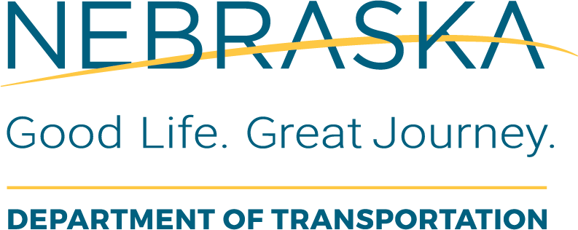 | Utilities  Final Utility Engineering Agreement Checklist
Instructions for Use: This form should be completed by NDOT LAD Project Coordinator once the LPA submits the completed final utility engineering agreement template they have negotiated with the Utility companies. NDOT requires that the LPA use the NDOT template agreement that is posted for use on Utility PE or CE projects.
Once this checklist is complete, the LAD PC will notify the NDOT PSS Section to adjust the funding obligation if necessary, in FMIS and will issue a Notice to Proceed to the LPA RC upon receiving approval on the obligation from FHWA.
Local Public Agency (LPA): |  | LPA Responsible Charge:
State Project No.: |  | Project Name and Location:
State Control No.: |  | Date of Review: | This Form was Completed By:

Task Description or Questions |  | Completed |  |  | If No, Define  Corrective Action | Details or Information Used to Verify Content | Additional Comments
 |  | Yes | No | N/A | If No, Define  Corrective Action | Details or Information Used to Verify Content | Additional Comments
1. | Has the Local Public Agency and the Utility Owner signed and dated the two original Agreements?
2. | Does the agreement reference the correct project/control numbers and existing agreement number ?
3. | Is the Agreement consistant with the standard template language? (ensure that there haven’t been any insertions or deletions to the standard template agreement) |  |  |  |  | Compare Standard NDOT Agreement Template to the Signed Agreement
4. | Are the costs identified in Part 4 of the Template Agreement, consistant with the Utility cost estimate attached as Exhibit B? |  |  |  |  | Standard NDOT Agreement Template
5. | Is the Non-Discrimination clause attached to the Agreement as "Exhibit A"?
6. | Has the approved Estimate been attached to the Agreement as "Exhibit B"?
7. | Has the approved Rehabilitation Plan been attached to the Agreement as "Exhibit C"?
8. | Has the LPA submitted a commitment to meet Local match? |  |  |  |  | Resolution

