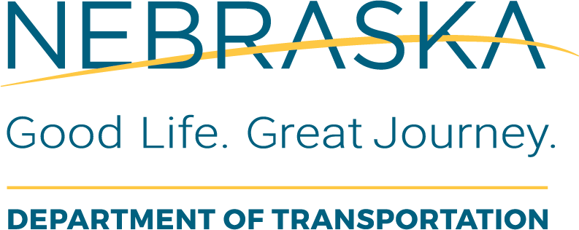 | Project Programming  ROW Obligation Verification Checklist
Instructions for Use: This form should be completed by the LAD PC in coordination with the NDOT ROW Division to verify the original ROW obligation.
Local Public Agency (LPA): |  | LPA Responsible Charge:
State Project No.: |  | Project Name and Location:
State Control No.: |  | Date of Review: | Checked By:

Item  # | Task Description or Questions | Completed |  |  | If No, Define  Corrective Action | Details or Information  Used to Verify Content | Additional Comments
Item  # | Task Description or Questions | Yes | No | N/A | If No, Define  Corrective Action | Details or Information  Used to Verify Content | Additional Comments
1. | Have the ROW plans, ROW cost estimate and Checklist 07-05 been forwarded to ROW and approved? |  |  |  |  | STIP/TIP located on the web
2. | Is the amount identified in the TIP/STIP still valid and in the current year of the STIP? |  |  |  |  | STIP/TIP located on the web
3. | Is the amount to be obligated based on acceptable data and an NDOT approved LPA ROW estimate? |  |  |  |  | ROW Estimate Checklist
4. | Are the ROW phase costs based on acceptable data, an approved ROW acquisition and relocation estimate, and include RC costs, consultant and/or in-house design costs, and any indirect administrative costs? |  |  |  |  | ROW Estimate Checklist

