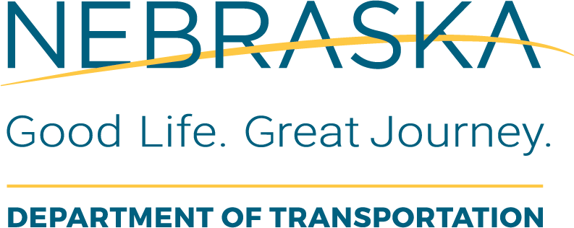 | Utilities  Final Supplemental Agreement for Construction and Construction Engineering Checklist
Instructions for Use: This form should be completed by NDOT LAD Project Coordinator once the LPA submits a draft supplement agreement for utility construction after the Utility PS&E package is accepted.
Local Public Agency (LPA): |  | LPA Responsible Charge:
State Project No.: |  | Project Name and Location:
State Control No.: |  | Date of Review: | This Form was Completed By:

Item  # | Task Description or Questions | Completed |  |  | If No, Define  Corrective Action | Details or Information Used to Verify Content | Additional Comments
Item  # | Task Description or Questions | Yes | No | N/A | If No, Define  Corrective Action | Details or Information Used to Verify Content | Additional Comments
1. | Has the Local Public Agency and the Utility Owner signed and dated the two Supplemental Agreements?
2. | Does the final supplemental agreement include all corrections made by NDOT?
3. | Was there any unauthorized editing or deleting of the standard template language?
4. | Does the agreement reference the correct project/control numbers and provide a sufficient project description?
5. | Are the costs identified the same as presented in the draft?
6. | Has the LPA submitted a commitment to meet Local match?
7. | Has a Request for Authorization been obligated in FMIS?
8. | Has an Notice to Proceed letter been prepared?

